First move the json file to hdfs ,

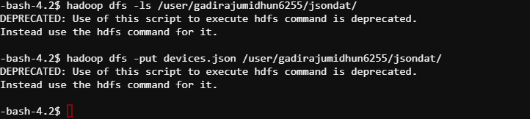

Then create the json table as shown below.

